Tertiary Infotech Academy Pte Ltd
UEN: 201200696W


LESSON PLAN
For

AWS Certified Machine Learning Engineer Associate Training
TGS Ref No: TGS-2024049340
Conducted by
Tertiary Infotech Academy Pte Ltd
UEN: 201200696W
Version 1

Document Version Control Record
Version Number | Effective Date of Release | Summary of Included Changes | Author
1 | 8 July 2026 | First AWS AWS MLA-C01 courseware build aligned to all 16 hands-on labs. | Tertiary Infotech Academy Pte Ltd

Course Details
Course Title | AWS Certified Machine Learning Engineer Associate Training
TGS Ref No. | TGS-2024049340
Duration | 2 Days (16 training hours)
Training Hours | 9:00 AM - 6:00 PM, including lunch and short breaks
Delivery Mode | Instructor-led classroom training with AWS hands-on labs
Learning Platform | AWS Management Console, AWS CloudShell, Amazon SageMaker AI and AWS documentation
Assessment | Knowledge checks, lab evidence and final readiness review
Learner Guide | LG-AWS Certified Machine Learning Engineer Associate Training.docx
Slide Deck | AWS Certified Machine Learning Engineer Associate Training-v1.pptx
Lab Source | labs/ folder, 8 markdown labs

Note: Every lab row references the exact final PPT slide range.

Learning Outcomes
- Prepare, ingest, transform and govern data for machine learning on AWS.
- Select, train, tune, evaluate and register models with SageMaker AI.
- Deploy real-time, serverless and batch inference workloads.
- Build MLOps pipelines and apply monitoring, security and cost controls.

AWS ML Engineering Workflow
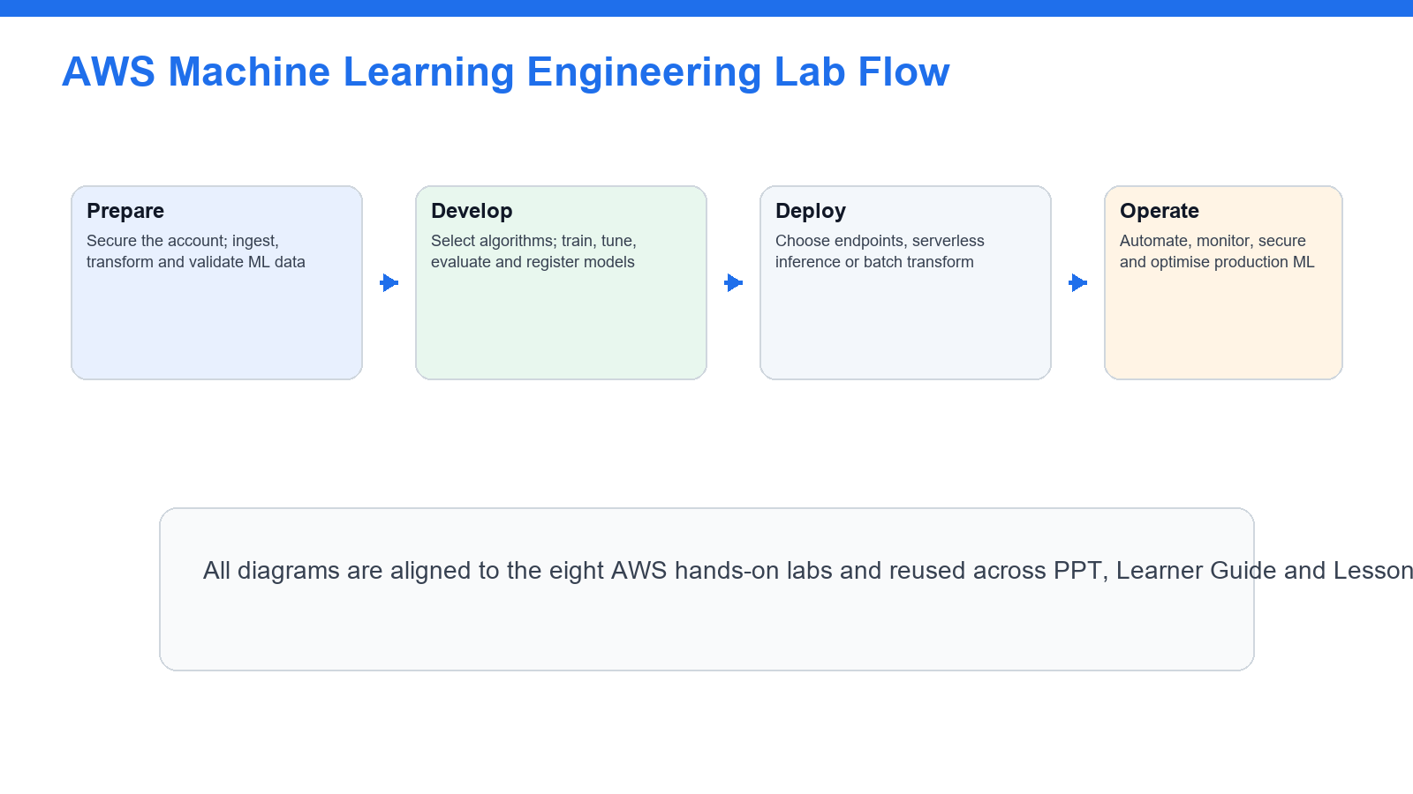
The labs follow the machine-learning lifecycle from governed data to monitored production inference.

Day 1
Time | Activity / Topic | Slides | Duration
9:00-9:30 | Administration, trainer introduction, attendance, objectives and assessment flow | 1-13 | 30 min
9:30-10:45 | Lab 1: Account safety, IAM, S3 ML data lake and data formats | 21-23 | 75 min
10:45-11:00 | Tea break | - | 15 min
11:00-12:30 | Lab 2: Data ingestion, transformation, feature engineering and quality | 24-26 | 90 min
12:30-1:00 | Review and evidence checkpoint | 21-26 | 30 min
2:00-3:20 | Lab 3: Modeling approach, SageMaker algorithms, JumpStart and AI services | 27-29 | 80 min
3:20-3:35 | Tea break | - | 15 min
3:35-5:20 | Lab 4: Training, hyperparameter tuning and Model Registry | 30-32 | 105 min
5:20-6:00 | Day 1 recap, validation and cleanup | 27-32 | 40 min

Day 2
Time | Activity / Topic | Slides | Duration
9:00-10:30 | Lab 5: Model evaluation, performance metrics and bias analysis | 33-35 | 90 min
10:30-10:45 | Tea break | - | 15 min
10:45-12:30 | Lab 6: Endpoints, inference infrastructure and batch transform | 36-38 | 105 min
12:30-1:00 | Deployment decision review | 33-38 | 30 min
2:00-3:30 | Lab 7: MLOps pipelines, CI/CD and orchestration | 39-41 | 90 min
3:30-3:45 | Tea break | - | 15 min
3:45-5:15 | Lab 8: Monitoring, security, cost optimization and exam review | 42-44 | 90 min
5:15-6:00 | Assessment readiness, learner evidence check and course close | 44-45 | 45 min

Trainer and Learner Actions
Phase | Trainer Action | Learner Action | Resources
Explain | Connect AWS services to the exam domain and demonstrate the target workflow. | Annotate the guide and identify the expected outcome. | PPT, AWS documentation
Practise | Facilitate each numbered step and monitor cost/security guardrails. | Complete every lab step in order and retain evidence. | LG, AWS account, SageMaker AI
Validate | Check expected results, troubleshoot and debrief design choices. | Run validation checks, capture evidence and clean up paid resources. | Lab validation and cleanup sections

